Little Heart Elementary
School Handbook
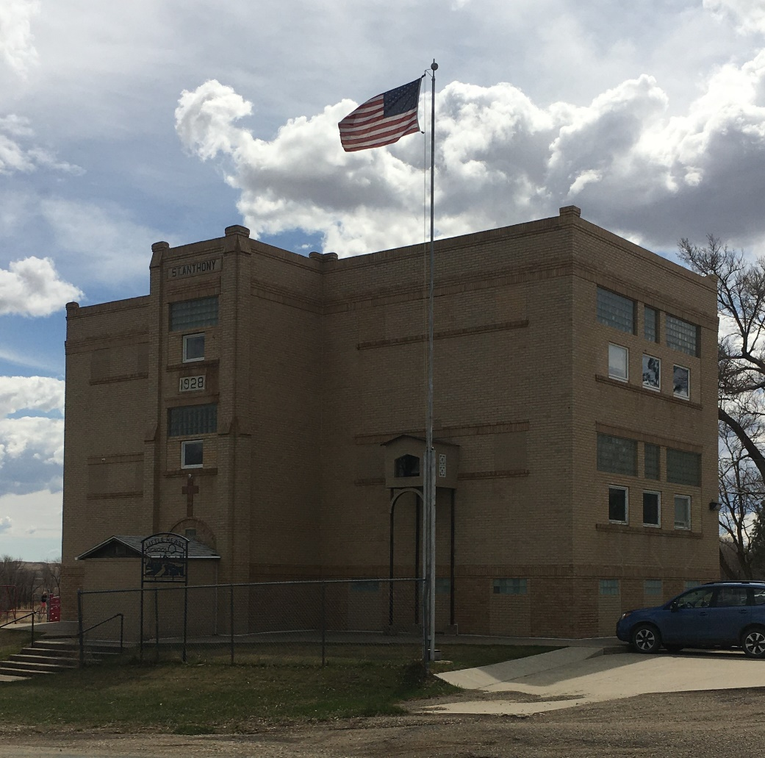

2025-2026

Dear Parents/Guardians,
This handbook was developed to acquaint you with the policies of Little Heart Elementary School as they pertain to you and your child. If questions arise concerning aspects of any of the school’s programs or policies, please refer to this handbook. If any further clarification is needed, please call the teachers or the school board.
**All changes are in bold type.
Little Heart Administration
School Board
Jesse Smith, President (C) 220-7522
Kelly Fisher, Vice President (C) 226-9508
Brandon Fisher, Director (C) 400-6576
Shelby Fisher, Director (C) 490-1560
Steve Stensgard, Director (C) 659-0912
Melissa Fisher, Business Manager (C) 220-0262
Michael Heilman, Superintendent (C) 527-4621
Teachers
Jennifer Vetter (C) 426-4185
Mary Cooper (C) 390-3425
Braylen Willows (C) 391-4085

***Contact by cell phone is for emergency use only.
Please contact teachers by phone, 445-7331 or email.
jennifer.vetter@k12.nd.us
mary.cooper@k12.nd.us
Braylen.willows@k12.nd.us

*We will be communicating with families through Remind, an app and texting tool, and the Little Heart Website. We will continue to post reminders and upcoming activities on both of these platforms.
Table of Contents:
Introduction 2
School Vision and Mission Statements 5
School Beliefs 5
School Hours and explanation 6
Attendance and Absences 7
Weather/Emergency Closings 8
Homework 8
Make-Up Work 8
Grading System 9
Report Cards 9
Promotion 9
Medications 10
Accidents & Illness in School 10
Accident Benefit Plan 10
Student Conduct 11
Dress Code 11
Bullying 11
Weapons 12
Care of School Property 13
Tobacco Use/Smoking 13
Cell Phone/Smart Watches 15
Headphone Usage 15
Discipline 15
Planners 16
Field Trips 16
Lunch 16
School Snacks 16
Change of Address/Phone Number 17
Fire Drills 17
Head Lice 17
Before/After School Program 17

Vision Statement
Our vision at Little Heart Elementary School is to provide authentic learning experiences that will enable and empower students to become lifelong learners and productive citizens.

Mission Statement
Our mission at Little Heart Elementary School is to ensure that all students are educated, self-directed, and productive members of society. Students will be educated and therefore able to apply skills and knowledge learned from a relevant standards-based core curriculum.

Beliefs
We believe:
- All students can achieve academic potential through effort, high expectations, and quality teaching.
- All students are entitled equal access to a free and appropriate public education.
- All students deserve to be treated with respect and dignity.
- All students will learn to work cooperatively and think critically and creatively to solve real life problems.
- All students have the right to learn at their own ability level and style.

School Hours
7:00-8:00 AM ----------Before School Program
8:30 AM ----------------School Begins
11:30 PM ---------------Lunch/Recess
12:20 PM -------------- Afternoon Classes Begin
3:05 PM ----------------School Dismisses
3:30-6:00 PM --------- After School Program
School days are Monday-Friday, for all grades K-8.
The school doors will be unlocked from 7:00 AM until 8:30 AM and 3:05 PM until 6:00 PM. Teachers will be responsible for the children in the classroom during the hours of 8:30 AM until 3:05 PM. All regular disciplinary rules and policies in this handbook will apply at this time. There will be teacher supervision inside the school and on the playground from 8:30 AM to 3:05 PM. Other than these hours they are not responsible for children on school property. Children should come to school as close to 8:30 AM as possible and be picked up, or go home, as soon as possible after school is dismissed at 3:05 PM. The Before School Program will run from 7:00 AM to 8:00 AM Monday through Friday. The After-School Program will run from 3:30 PM to 6:00 PM Monday through Thursday and 3:30 PM to 5:30 PM on Friday, except for school holidays and other days when there is no school. The after-school program may be cancelled due to bad weather conditions (blizzards being the most likely). Parents will be advised of this by 2:30 on such days.

School Policies
ATTENDANCE/ABSENCES
For students to be successful in school, it is essential they attend school every day and be on time. Research supports attendance as the most important predictor of student success.
A student is allowed 10 absences per semester or a total 20 absences per year. Any absence beyond that may result in retention at the discretion of the administration/school board. A letter will be sent after 10 absences indicating the possible consequences.
The Little Heart School day consists of two periods: the morning and afternoon sessions.
- If a student arrives in class between 8:40 and 10:00, they will be tardy. If they arrive after 10:00, the student will be counted absent for the morning session.
- If a student leaves before 2:00, he/she will be counted absent for the afternoon session.
- In addition, three tardies will equal one day of absence counted towards your total absences.
Parents need to communicate with the school each time a child is absent. Phone calls, Remind App, and handwritten notes are all acceptable forms of communication. For the safety of your child, it is essential that this communication comes from a parent/guardian only.
Failure to communicate by 9:00 AM (or a half hour after school begins) will result in an unexcused absence regardless of the reason. Safety calls will be made after 9:00 (or a half hour after school begins) and will not change the student’s unexcused absent code. If we are unable to reach a parent/guardian at this point, we will be calling for a safety check. Safety checks will be conducted by the school’s resource officer. After consecutive instances or a repetitive pattern where the school needs to make a safety call, you may need to meet with the school board to discuss your communication and come up with an action plan.
Excused absences include illness, injury, school related activity, family trips with prior notification (enough time for teachers to gather homework ahead of time if needed), family emergencies, or religious observances.
An unexcused absence results when the conditions for an excused absence are not met. An unexcused absence includes any condition that is not listed under the excused absence exceptions.
Illness is coded as parental request. When a student is ill, after 3 consecutive parental requests, the student may need a note from a doctor to return to school. If a doctor’s note is not turned in, the absences may be coded unexcused.
Excessive absences may result in the school referring the student to Morton County Social Services, Child Protective Service (MCSS, CPS.)

WEATHER/EMERGENCY CLOSINGS
In case of bad weather, parents should use their own good judgment in whether to send their children to school. Information about cancellations and late starts/early dismissals will be communicated via phone tree and school communication tools.

HOMEWORK
In general, there is little assigned homework. This policy is based upon the assumption that if elementary school students put in a full school day of honest effort, they should have time at home for other interests. However, older children may expect a minimal amount of homework.
Exceptions to the general practice would be make-up work after an absence, additional help for the slow or rapid learners, or special assignments.

MAKE-UP WORK
For all make-up work, the student will be given two days for each day they are absent. If it is not made up in that time it will result in a grade reduction.

GRADING SYSTEM
The following grading system will be used:
K-1st
E = Excellent
S+ = Satisfactory Plus
S = Satisfactory
U = Unsatisfactory
2nd – 8th
A+ 99 – 100% C+ 83 – 84%
A 95 – 98% C 79 – 82%
A- 93 – 94 % C- 77 – 78%
B+ 91 – 92% D+ 75 – 76%
B 87 – 90% D 72 – 74%
B- 85 – 86% D- 70 – 71%
F 0 – 69%

REPORT CARDS
Report cards will be issued at the close of each nine-week period through the PowerSchool grading system. Parent/teacher conferences will be scheduled twice a year. (After the first quarter and mid-term of third quarter.)

PROMOTION
We believe that whenever possible a child should progress to the next grade level with their peers. Occasionally, it will be necessary to retain a child in the same grade level another year. The decision will be based upon the child’s ability to successfully achieve grade level standards in all subject matters. Students who fail 3 of the 4 core subjects (Math, Reading, Science, and Social Studies) may be retained. Their physical, social, emotional, and intellectual needs are also taken into consideration. The number of days absent can contribute to this decision as well.
Every effort will be made to confer with parents regarding children who are experiencing academic difficulties. You have 15 days to appeal the decision made by the board.
If any problems with a student’s progress in school arise, a parent-teacher conference can be arranged upon the request of the parent or teacher.
MEDICATIONS
State health regulations require medications, both prescription and over the counter, to be handled in certain ways.
If your child is on a daily prescription medication, we will need a photo- copy of the prescription, the dosage, and times that you give your child the medication.
If your child will be taking any medication temporarily (prescription or over the counter) while in school, it must come in the original package with a note when to administer and a parent signature.
Any medications and notes regarding medications should be given to the student’s teacher or principal before the school day begins.
Do not have your child keep the medication themselves.
Do not send medication without the original package.

ACCIDENTS & ILLNESS IN SCHOOL
In an event that your child is involved in an accident or becomes ill at school, first aid will be administered by the teachers. If the accident or illness is of serious nature, parents will be called. If the school is unable to contact parents, the student will be taken to a local physician. If the nature of the accident or illness is minor, the child will remain in school.

ACCIDENT BENEFIT PLAN
The Little Heart School District carries accident benefit coverage for all students throughout the school system through NDIRF. Claims are sent in by the teachers in charge, who act merely as the reporting agents. It is vitally important that the students report accidents immediately to the teacher in charge of the group to ensure that the proper forms are filed. If the student is hospitalized or consults more than one doctor, claims must be sent to each. This does not cover broken glasses. The School Board handles all claims.

STUDENT CONDUCT
- Students are expected to be respectful to all teachers, staff, and peers.
- Classes should not be disrupted by teachers or students from other classrooms.
- Shouting, running, whistling, or scuffling are not allowed.
- Hallways and doorways are not to be obstructed.
- Candy, pop, sunflower seeds, etc. are not allowed in school.
- Comic books, toys, personal belongings, etc. must remain in backpacks.
- Party invitations or gifts are not allowed to be passed out during school hours, unless every student is being included.
- No bullying, fighting, name-calling or foul language is allowed.
DRESS CODE
Students are required to have two pairs of shoes for school, indoor and outdoor shoes. Their inside shoes must have non-marking soles and will remain at school and be changed into when coming in and out of the school. Students are required to wear tennis shoes in the gym (these can be their indoor shoes, as long as they are tennis shoes).
During wet weather students will be required to wear over-shoes or boots. During winter weather students must have boots, snow pants or snow suits, cap and mittens or they will not be allowed to go out for recess. Please see our “What to Wear for the Weather” chart included at the end of this handbook for our K-5 guidelines.
No caps or hats are to be worn inside the school building.
BULLYING
Definition of bullying as stated in the North Dakota Century Code.
Section 1. A new section to chapter 15.1-19 of the North Dakota Century Code is created and enacted as follows:
Bullying – Definition
As used in this Act:
- “Bullying” means:
- Conduct that occurs in a public school, on school district premises, in a district owned or leased school bus or school vehicle, or at any public school or school district sanctioned or sponsored activity or event and which:
- Is so severe, pervasive, or objectively offensive that it substantially interferes with the student’s educational opportunities;
- Places the student in actual and reasonable fear of harm;
- Places the student in actual and reasonable fear of damage to property of the student; or
- Substantially disrupts the orderly operation of the public school; or
- Conduct that is received by a student while the student is in a public school, on school district premises, in a district owned or leased school bus or school vehicle, or at any public school or school district sanctioned or sponsored activity or event and which:
- Is so severe, pervasive, or objectively offensive that it substantially interferes with the student’s educational opportunities;
- Places the student in actual and reasonable fear of harm;
- Places the student in actual and reasonable fear of damage to property of the student; or
- Substantially disrupts the orderly operation of the public school.
- “Conduct” includes the use of technology or other electronic media.
Complaints must be filed through the proper channels. You may ask administration for the forms or find the forms on the North Dakota School Board Association website. If you wish to read the policy in full, it is on file with the school administrator.
WEAPONS
The Little Heart School Board has determined that the possession and/or use of a weapon by a student is detrimental to the welfare and safety of the students and school personnel within the district.
No Student will knowingly possess, handle, carry, or transmit any weapon or dangerous instrument in any school building, on school grounds, in any school vehicle or at any school-sponsored activity. Such weapons include, but are not limited to, a knife, razor, ice pick, explosive, smoke bomb, incendiary device, gun (including pellet gun), slingshot, bludgeon, brass knuckles, or any object that can reasonably be considered a weapon or dangerous instrument.
Violation of this policy will result in disciplinary action. All weapons will be confiscated and may be turned over to the student’s parents or to law enforcement officials at the discretion of the administration.
Bringing a firearm, as defined in 18 U.S. C. 921, to school will require that proceedings for the expulsion of the student involved for a minimum of one year be initiated immediately by the principal. The Superintendent may recommend a modification of the expulsion on a case by case basis. This modification shall be based on the circumstances revealed in the investigation into the incident conducted by the Superintendent or other person designated by the Superintendent to conduct the investigation. (Alternate education may be provided for students who are expelled under this section.) The principal or school board will notify law enforcement.
Other violations of this policy will require that proceedings for the suspension and/or expulsion until the end of the current school term be initiated immediately by the principal.
Proper due process proceedings as defined as in Policy FHDA (Suspension and Expulsion) will be observed in all suspensions and expulsions under this policy.
A student who is defined as having a disability under the Individuals with Disabilities Education Act may be placed in an alternative educational setting for up to 45 calendar days during which time a determination will be made as to whether bringing the firearm to school was a manifestation of the student’s disability. Discipline and placement of the student will be in accordance with the Individuals with Disabilities Education Act.

CARE OF SCHOOL PROPERTY
The school furnishes textbooks, workbooks, and library books for all students. It is very important that the students take good care of these books and all school property. All school property, including desks, playground equipment, books, iPads, etc. will be the student’s responsibility. If any of these properties are damaged, the student responsible will be charged for the replacement value of the damaged items.

TOBACCO USE/SMOKING
In compliance with North Dakota State Law, smoking is not permitted in the school buildings or on the school grounds. Students carrying cigarettes to school are subject to suspension.

Rationale for regulating possession and use:
The health hazards of tobacco use have been well established. This policy is established to:
- Reduce the high incidence of tobacco use in North Dakota.
- Protect the health and safety of all students, employees, and the general public.
- Set a non-tobacco use example by adults.
Tobacco use is the leading cause of preventable death and disability in North Dakota. To support and model a healthy lifestyle for our students, Little Heart School Board has established this tobacco-free policy.
Definition:
For the purpose of this policy, “tobacco” is defined to include any product that contains tobacco, is manufactured from tobacco, or contains nicotine. This excludes any FDA-approved nicotine replacement therapy.
Use and Possession Prohibits:
Students
Possession and/or use of tobacco products by students on district property, in district vehicles, and at school-sponsored events (whether on or off school property) is prohibited at all times.
Staff/Visitors
The use of tobacco products by all school employees and visitors on district property, in district vehicles, and at school-sponsored events (whether on or off school property) is prohibited at all times.
This policy includes all events sponsored by the school and on school property as well as all events not sponsored by or associated with the school.
The school district will not allow advertising of tobacco products in the school buildings, on school property, at school functions on school property, and in all school publications. This includes clothing that advertises tobacco products. The Little Heart School District will not accept any gifts such as curriculum, book covers, speakers, etc. or funds from the tobacco industry.
All individuals on the districts premises share in the responsibility for adhering to and enforcing this policy. The Principal and School Board will develop regulations for the enforcement and implementation of this policy.
Individuals requesting assistance with tobacco cessation services will be referred to North Dakota Tobacco Quit line or North Dakota QuitNet. These are free cessation services provided to citizens of North Dakota.
CELL PHONES/SMART WATCHES
Students may have a cell phone at school; however, it must be off and in their backpacks between the hours of 8:30 AM and 3:05 PM. If the phone is on or out of the backpack between these times it will be confiscated by a teacher and a parent will have to come pick it up. After the second violation the situation will be brought before the school board.
Smart watches may be worn throughout the day, but the smart features of the watch must follow the same guidelines as a cell phone.

HEADPHONE USAGE
All students will be given a pair of headphones at the start of school to use throughout the year. If the headphones are broken or damaged in any way, the student will be held responsible and must replace them. Headphones should last for four or more years. After this amount of time, the student will be given a new pair if necessary.
DISCIPLINE
In order to offer our children the best education possible, and for our children to develop to their potential, we need to work together to maintain a safe and positive environment; an environment that enables teachers to teach and all students to learn. To ensure safety and the school’s educational effectiveness, a discipline policy has been set in place. If a rule is broken, the student will be made aware of the violation by the teacher and appropriate steps to move forward will be taken. These steps may include verbal warnings, loss of recess time, fixing of property, giving additional help to teachers, and apologies will be issued. For major infractions parents will be notified immediately. Repeat infractions may include a phone call to the parent by the student and/or teacher.
If any problems with discipline in school arise, a parent-teacher conference can be arranged upon the request of the parent or teacher.
All incidents will be documented. If necessary, a behavior modification plan will be agreed upon between the student, teacher, and parent.

PLANNERS
Each student 3rd-8th will be provided a planner. These will be used as a way for teachers to communicate with parents and also as a daily homework reminder for the students. Parents should ask to see their child’s planner each evening. If the planner is lost it will be replaced by the school and the student will be charged $3.00 for the replacement.

FIELD TRIPS
Classes will be taking field trips throughout the year. Parental consent is necessary before a student may take part in a trip. Permission slips will be sent home prior to the field trip. These must be completed and signed by a parent/guardian and returned to school by the date requested. Student behavior leading up to the field trip will determine whether a student is eligible to attend the field trip.

LUNCH
There is no hot lunch program at school. Students are required to pack their own lunch each day. If a student forgets their lunch there will be something at the school for them to eat. Students will be charged $3.00 for each lunch served.

SCHOOL SNACKS
Child obesity has become a nationwide concern. Research indicates that students do better in school when they have 9-10 hours of sleep, a balanced diet, regular exercise, and limit the amount of foods high in carbs, sugar, and fat. Little Heart School encourages all students to bring healthy snacks. Listed below are some healthy choices to help guide you when deciding on your child’s snack:
Raw fruits and vegetables, cheese, dried fruit, trail mix, granola bars, jello/fruit cups, applesauce, low fat puddings, yogurt/gogurt, low fat crackers, pretzels, jerky, nutri-grain bars, rice cakes, chex mix.
Please limit the amount of sugary and candy snacks sent as it can affect your child’s learning later in the day.

CHANGE OF ADDRESS/PHONE NUMBER
If a family changes address or telephone during the year they must notify the school immediately so that records may also be changed.
FIRE DRILLS
North Dakota State Law requires that four fire drills be held throughout the year. Fire drills will be held as weather conditions permit. When the fire alarm sounds, students should proceed to the nearest exit or to the exit designated by the teacher. Stay clear of the building until the all-clear signal is given.
HEAD LICE
Little Heart School along with the Custer Health Unit will follow the No Nit Policy to handle head lice issues. The student must have written permission provided to the school from either a doctor or a county nurse in order to return to school. The student will be reevaluated in approximately 10 school days after returning to school.
BEFORE/AFTER SCHOOL PROGRAM
Little Heart School offers a before and after school program for all students, as a need only basis. This program offers school staff from 7:00 AM – 8:00 AM and 3:05 PM – 6:00 PM Monday through Thursday and from 7:00 AM – 8:00 AM and 3:05 PM – 5:30 PM on Friday. Parents must inform the school if their child will be arriving early or staying late. Starting at 3:30, parents will need to sign for their child(ren).
Students can be dropped off any time after 7:00 AM. Students must be picked up by 6:00 PM, Monday through Thursday and by 5:30 PM on Fridays.
If not picked up on time, there will be a $25.00 fee for each 15 minutes you are late.
There is no after school program on days that there is no school and school holidays. These holidays include Christmas Program Day, Play Day, Mother’s Day Tea and The School Picnic. It may also be cancelled due to bad weather conditions. Remember to make arrangements for your child on these days. If your child/children are not picked up there will be a $25.00 charge for each 15 minutes you are late.
Tardy #1 – Warning
Tardy #2 – Late fee payment of $25 for every 15 minutes.
Tardy #3 – Late fee payment of $25 for every 15 minutes. A week suspension from the before and after school program.
Tardy #4 – Late fee payment of $25 for every 15 minutes. The loss of before and after school privileges for the remainder of the school year.
Future attendance for before and after school privileges will be reviewed by the school board. All decisions are final.

